OPEN PBS

IN Master

https://github.com/openpbs/openpbs/blob/master/INSTALL#L22

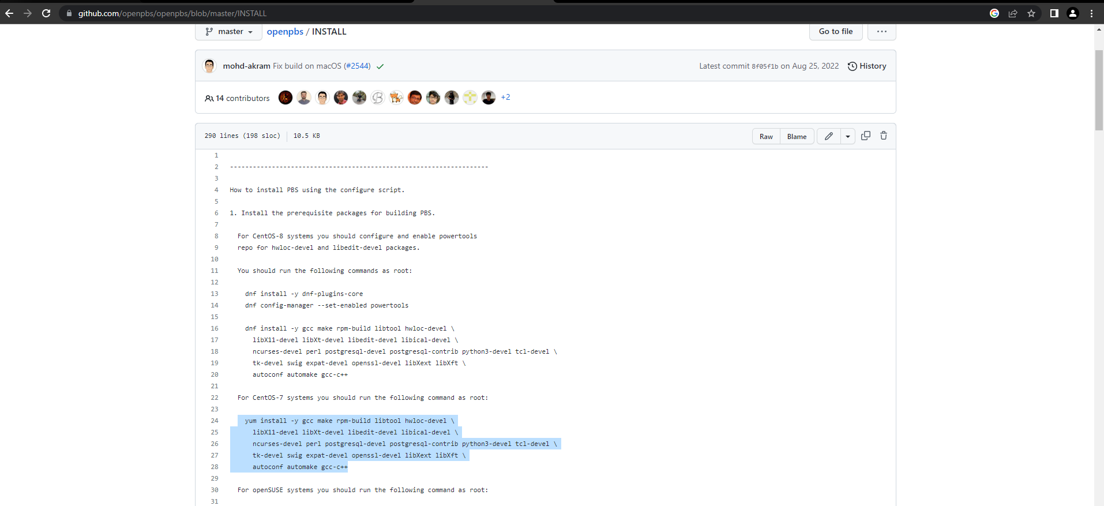

yum install -y gcc make rpm-build libtool hwloc-devel \

libX11-devel libXt-devel libedit-devel libical-devel \

ncurses-devel perl postgresql-devel postgresql-contrib python3-devel tcl-devel \

tk-devel swig expat-devel openssl-devel libXext libXft \

autoconf automake gcc-c++

|  |
| --- |
|  |
|  |
|  |
|  |
|  |
|  |  |

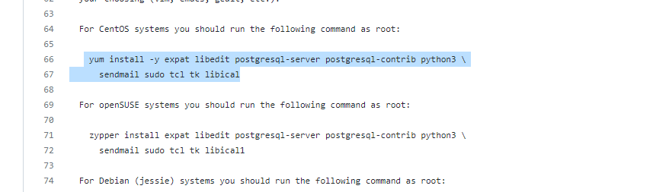

|  |
| --- |
|  |
|  |  |

yum install -y expat libedit postgresql-server postgresql-contrib python3 \sendmail sudo tcl tk libical

<https://github.com/openpbs/openpbs/releases/tag/v20.0.1>

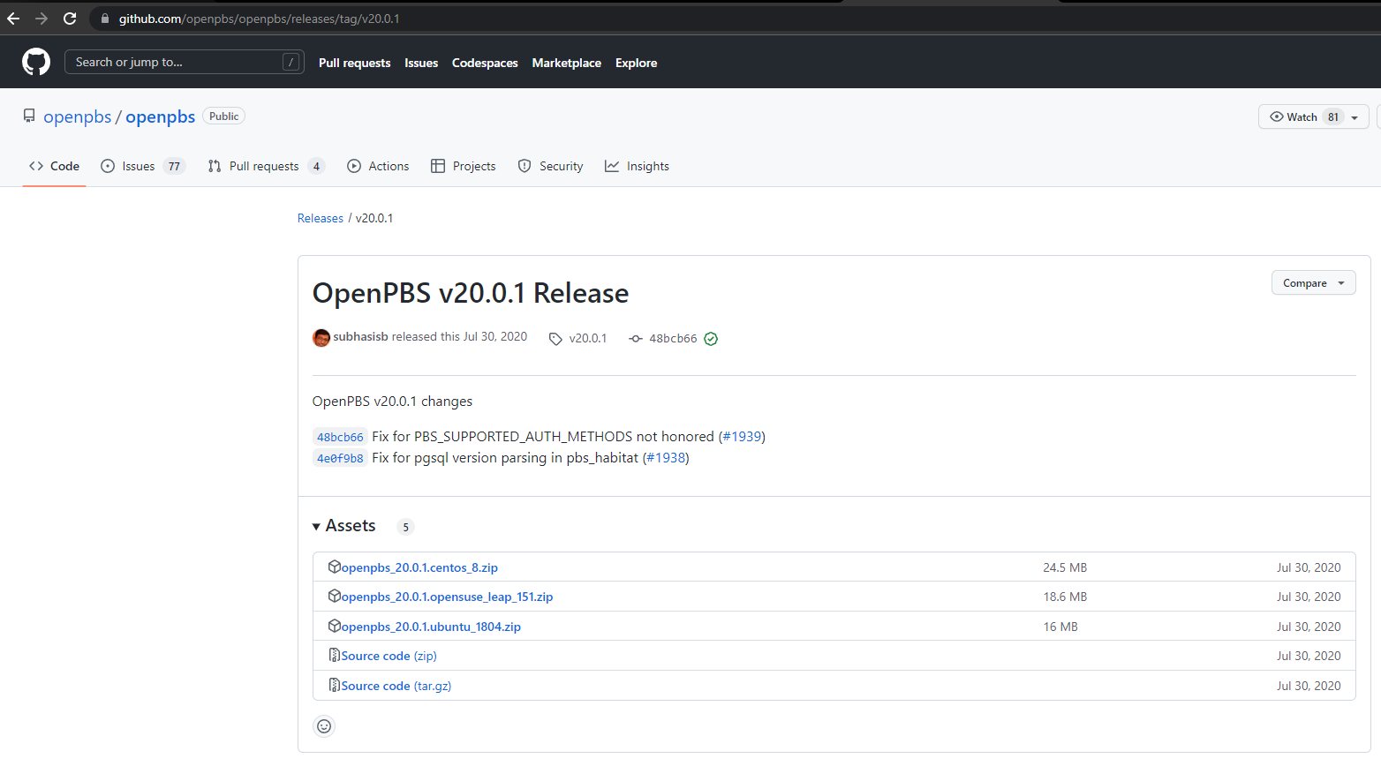

* wget <https://github.com/openpbs/openpbs/archive/refs/tags/v20.0.1.tar.gz>
* mv v20.0.1.tar.gz openpbs-20.0.1.tar.gz
* yum install libtool-ltdl-devel –y
* rpmbuild -ta openpbs-20.0.1.tar.gz
* cd /root/rpmbuild/RPMS/x86_64/
* rpm -ivf openpbs-server-20.0.1-0.x86_64.rpm
* vi /etc/pbs.conf

*[root@master x86_64]# vi /etc/pbs.conf*

*PBS_EXEC=/opt/pbs*

*PBS_SERVER=master*

*PBS_START_SERVER=1*

*PBS_START_SCHED=1*

*PBS_START_COMM=1*

*PBS_START_MOM=1*

*PBS_HOME=/var/spool/pbs*

*PBS_CORE_LIMIT=unlimited*

*PBS_SCP=/bin/scp*

* /etc/init.d/pbs start
* . /etc/profile.d/pbs.sh
* useraddd hpcsa
* su - username
* qsub –I
* scp -r /root/rpmbuild/RPMS/x86_64/ root@client1:/home/
* scp -r /root/rpmbuild/RPMS/x86_64/ root@client2:/home/
* ssh client1

IN CLIENT OR NODE

* cd /home/x86_64/
* rpm -ivh openpbs-execution-20.0.1-0.x86_64.rpm
* cd /var/spool/pbs/mom_priv/config

*enter clientname*

IN MASTER

* cd /var/spool/pbs/server_priv/config

*nodename np=1*

*nodename np=2*

* su – username
* qsub –I

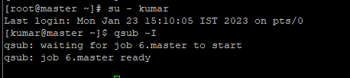

* pbsnodes –a #show nodes in master

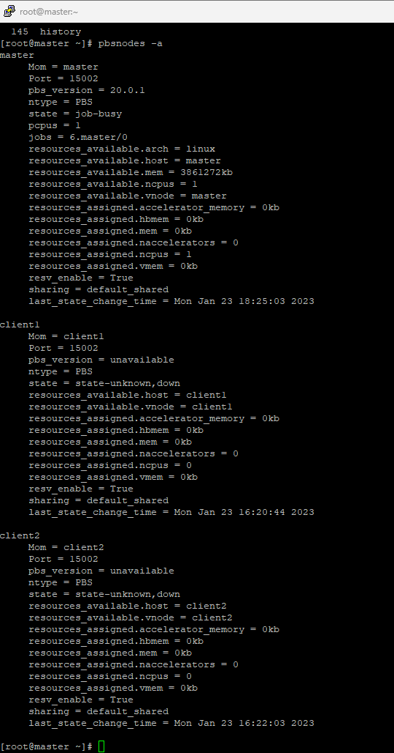

IN MASTER USER

* qmgr (create a routing queue)

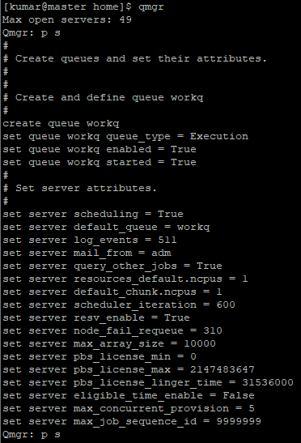

* qstat

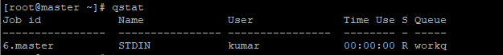

* chown root script.sh
* vi script.sh

*#PBS -N Kam (name of job)*

*#PBS -l nodes=1:ppn=1 (resources allocated, 1 node 2 processors)*

*#PBS -l pmem=2gb (memory per core)*

*#PBS -l walltime=00:10:00 (job will run at most 10 min)*

*#PBS –q workq (job is submitted to workq queue)*

*#PBS -o opfile.out (output file is named opfile.out)*

*#PBS -j oe (output and error is combined into the same file)*

*/bin/hostname*

*sleep 120*

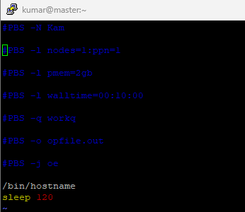

* qsub script.sh
* qstat
* qstat -ans

